4.09 Merge
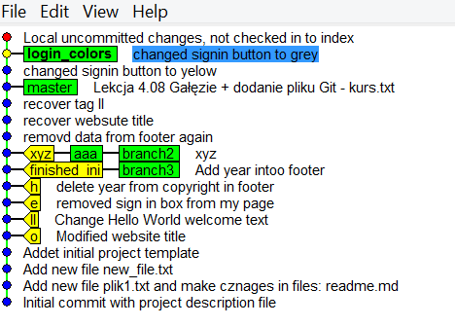

$ git checkout master
$ git merge login_colors

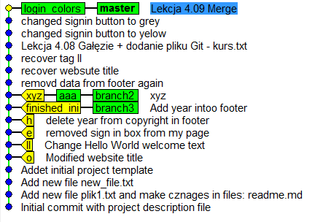

$ git branch -d login_colors
$ git branch -d aaa
$ git branch -d branch2

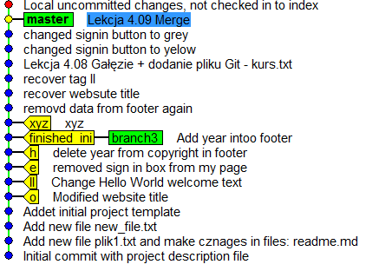

$ git branch -d branch3

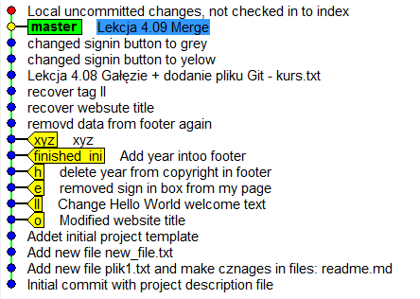

$ git checkout -b test
$ git checkout -b test_colors
Piotr@laptopAsus MINGW64 /c/DEV/Kurs_gita/my_projects (test_colors)

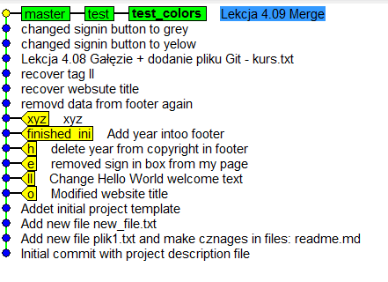

$ git commit . -m "Yellow button"
[test_colors 343b0d5] Yellow button
1 file changed, 1 insertion(+), 1 deletion(-)

